**ANSWER:**

**ANSWER:**

Find the units digit of .

How many multiples of 7 are there between 100 and 200?

10/3 **Using the Integers**

Name: ________________________

**Pair Ciphering #2**

**5 points 10 points**

10/3 **Using the Integers**

Name: ________________________

**Pair Ciphering #1**

**5 points 10 points**

**ANSWER:**

**ANSWER:**

A store sold 72 decks of cards for $a67.9b. Find a + b.

Given that , how would you represent 531440 in base 9?

10/3 **Using the Integers**

Name: ________________________

**Pair Ciphering #4**

**5 points 10 points**

10/3 **Using the Integers**

Name: ________________________

**Pair Ciphering #3**

**5 points 10 points**

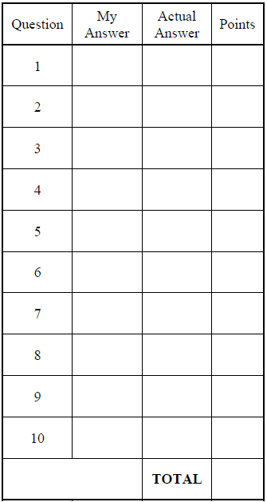

If a set of markers in placed in rows of 4 each, there are 2 markers left over; if in rows of 5 each, there are 3 left over; and if in rows of 7 each, there are 5 left over. What is the smallest number of markers that the set could contain?

10/3 **Using the Integers**

Name: ________________________

**Pair Ciphering #5**

**5 points 10 points**

**ANSWER:**