**ANSWER:**

**ANSWER:**

If triangle PQR has sides 40, 60, and 80, then the shortest altitude is **K** times the longest altitude. Find the value of **K**.

How many **scalene** triangles have all sides of integral lengths and perimeter less than 13?

8/27 **Triangle Geometry**

Name: ________________________

**Ciphering #2**

**5 points 10 points**

8/27 **Triangle Geometry**

Name: ________________________

**Ciphering #1**

**5 points 10 points**

**ANSWER:**

**ANSWER:**

The sides of △BAC are in the ratio 2:3:4. BD is the angle bisector drawn to the shortest side AC, dividing it into segments AD and CD. If the length of AC is 10, then find the length of the longer segment of AC.

Triangle ABD is right-angled at B. On AD there is a point C for which AC = CD and AB = BC.

Find ∠DAB.

8/27 **Triangle Geometry**

Name: ________________________

**Ciphering #4**

**5 points 10 points**

8/27 **Triangle Geometry**

Name: ________________________

**Ciphering #3**

**5 points 10 points**

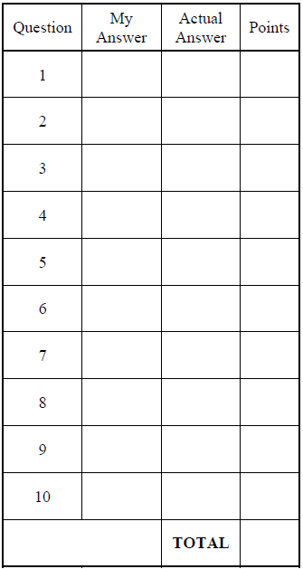

In this figure, ∠ACD is a right angle, A, B, and C are collinear, ∠A = 30˚, and ∠DBC = 45˚.

If AB = , find the area of △BCD.

8/27 **Triangle Geometry**

Name: ________________________

**Ciphering #5**

**5 points 10 points**

D

C

B

A

**ANSWER:**